Tyntesfield P.S.
PESP report July 2023



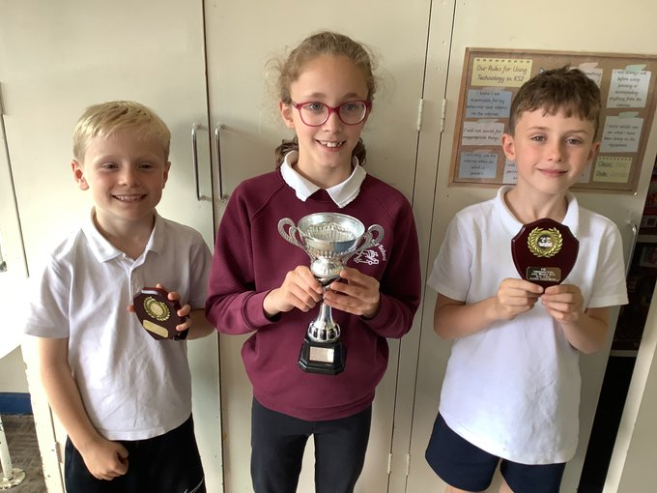
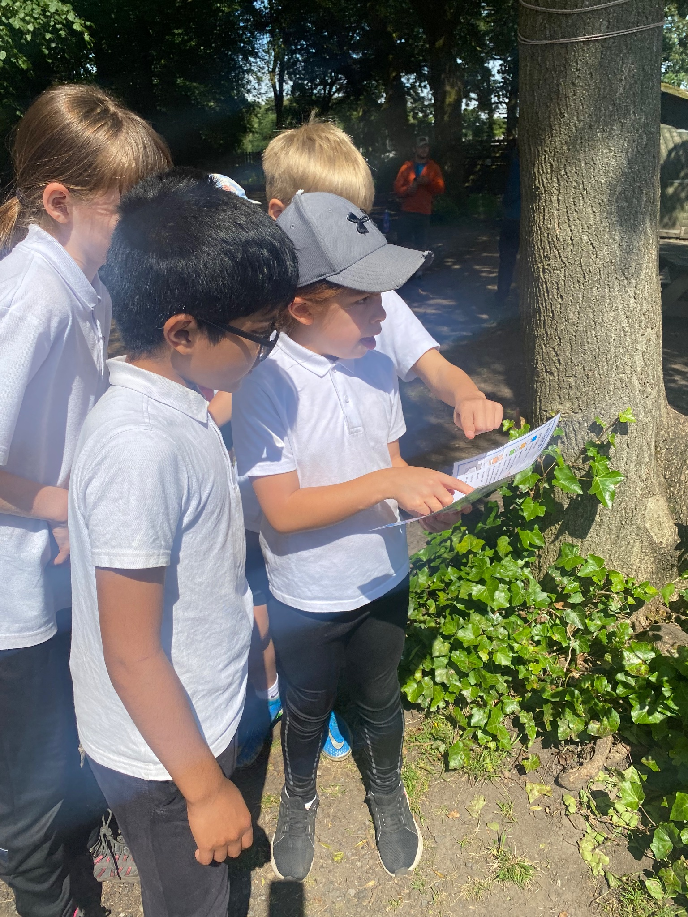
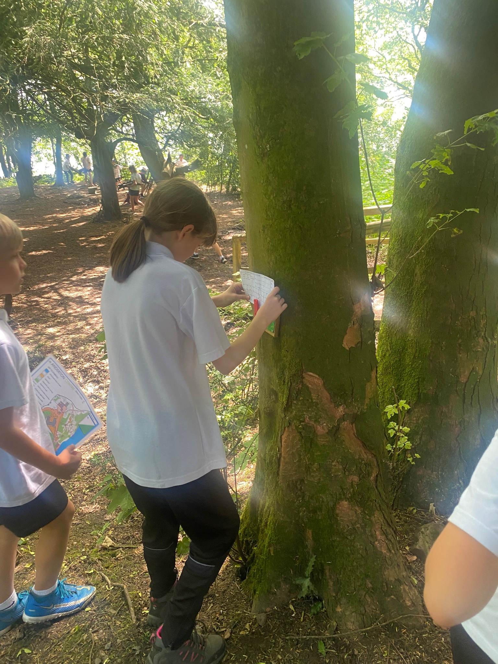


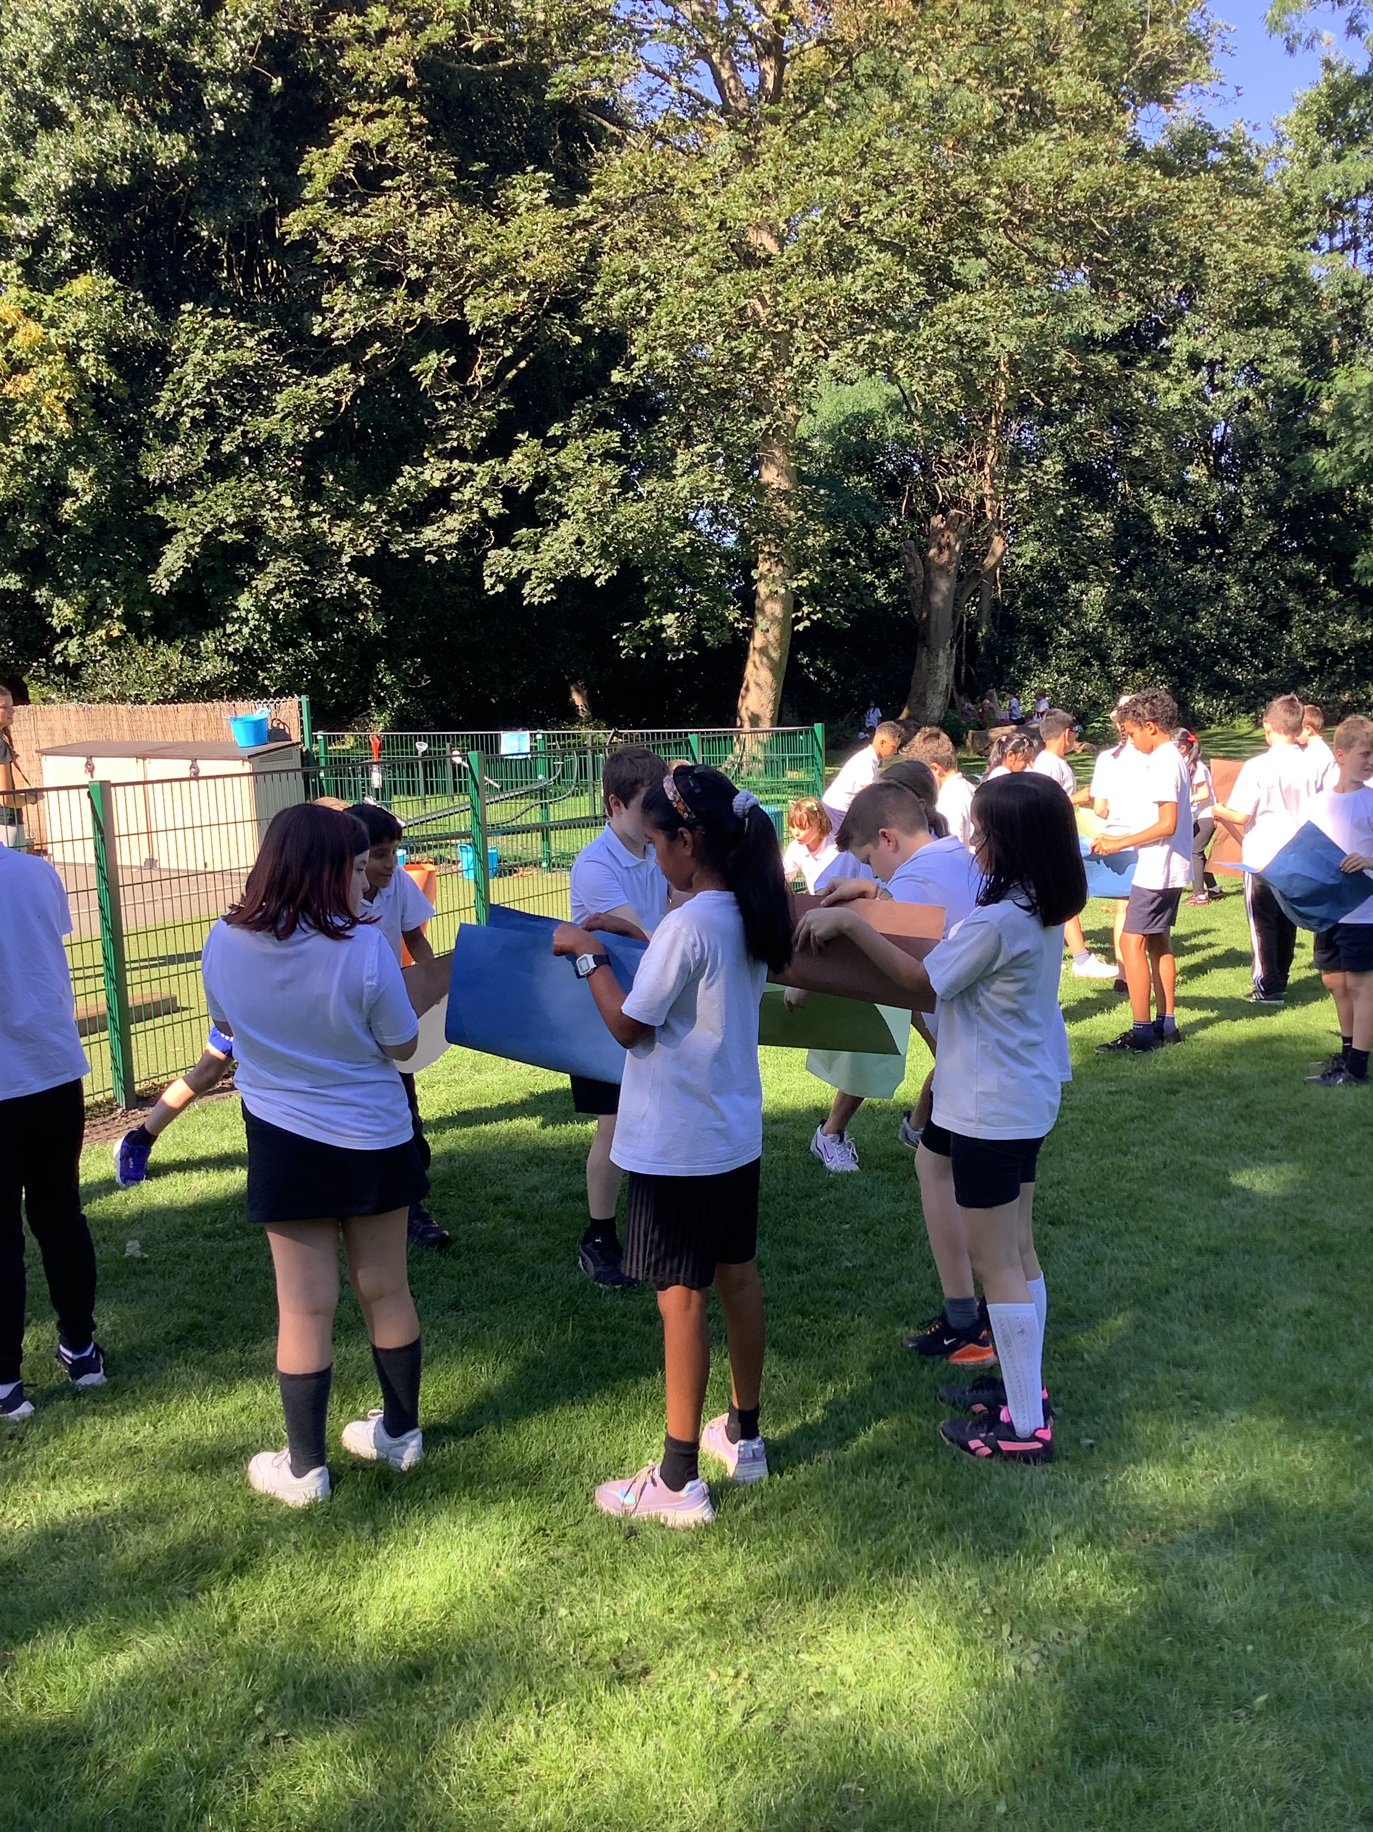

Review of last year’s spend and key achievements (2022/2023)

We recommend you start by reflecting on the impact of current provision and reviewing your previous spend.

Activity/Action | Impact | Comments
- Buying in staff to support the provision of high- quality teaching and learning.  Indicator 1  - Purchased a scheme of work- The Primary PE Passport  Indicator 1 & 4  - Bought into the Premium package of the School Sports Partnership  Indicator 3, 4 & 5  - School has managed to get up to a full complement of clubs before school and after school.  Indicator 2.4 & 5  - Purchase of new equipment  Indicator 2&4.  - Clearer pedagogy in EYFS. | Through the PE and Sports Hub, Mr Drazkowski has been able to upskill the teaching staff and model high- quality teaching and learning. As a consequence, we believe standards of T and Learning in PE lessons are high.  The Passport is full of ideas for the non- specialist. Lessons are progressive and cover a range of traditional and new sports. The software tracks participation and competition.  Children across the school have been able to participate in many fixtures, events and tournaments commensurate with their ability. Mr Moss has been able to attend meetings which share good practice and to network with other PE leads  Many of the new clubs are targeted particularly around provision for the younger children which has meant more of the younger children have been active and are forming good active habits at an earlier age.  Children have had more equipment and of better quality. This means that they are using age appropriate equipment.  The children have been working through The Pippa and Eddie scheme and are doing a daily mile every day after Phonics | Mr Rogerson, ‘Working alongside a specialist is just great for the children and means that for us, as a staff, we are learning from Mr D whilst getting opportunities to deliver and take feedback from him.’  As PE lead I can use the software and monitor that we are catering for all children’s needs.’ Mr Moss  We enter elite and School Games Values events aimed at the less sporty children. It means everyone can compete enjoyably at their own level.’ Mr Rogerson  ‘I value opportunities to share good practice across the borough with other subject leads.’ Mr Moss  ‘Having a Sports Parliament and doing regular Pupil Voice has helped shape our offer to meet the needs of the children.’  Mr M  ‘ Having new equipment including a Boom Box in the infants has meant we have had more children joining in our Groovy Discos on Tuesdays.’ Mrs_McDonald  ‘The children loved P&E. We have seen the children acting out its content during continuous provision. Doing a Daily Mile is something the children really enjoy; it energises them.’ Mrs McDonald

Key priorities and Planning
This planning template will allow schools to accurately plan their spending.

Action – what are you planning to do | Who does this action impact? | Key indicator to meet | Impacts and how sustainability will be achieved? | Cost linked to the action
Ensure that as many children from Tyntesfield P.S. get the opportunity to play /perform in competitive, inclusive sport.  Continue to employ a PE specialist who can provide high quality teaching and learning and upskill the staff  Look at quality of the Playground environment to make it as safe and vibrant as possible.  More opportunities to monitor standards of teaching and learning | All children  Staff and children  Teachers, children, MDAs  Staff and children | - & 5 Increased participation in competitive sport and 5. Broader experience of a range of sports and activities offered to all pupils  - Increased confidence, knowledge and skills of all staff in teaching PE and sport  - & 5 The engagement of all pupils in regular physical activity  1& 3 The profile of PE and sport is raised across the school as a tool for whole-school improvement | We hope to enter lots of Elite and SV events and this can be sustainable by forming close relationships with other local schools  We hope that by upskilling staff they will be able to seamlessly take over should the funding go.  Children will be motivated to be active and have more variety to play safely.  Staff will value feedback from PE lead and develop their practice. | £3000 (SSP membership and transport)  £11,000  £1500  £800

Key achievements 2023-2024
This template will be completed at the end of the academic year and will showcase the key achievements schools have made with their Primary PE and sport premium spending.

Activity/Action | Impact | Comments
- Achieving Platinum standard of the School Games Mark  - Increased opportunities for pupil leadership in lessons and around school particularly for girls. This included Playground Leader training led by Trafford SSP as well as attending training at Old Trafford. Also having a Sports Parliament  - Walk to School Year  - New inclusive opportunity- children attended Ten Pin bowling competition at Atlantic Bowl. | This is a prestigious award for the school and reflects the excellent practice across the school in PESSPA  Children feel more involved and that they have a bigger say in all things PE at Tyntesfield  There was a huge commitment form parents and children to walking to school all week.  The 10 children who attended were so excited to be representing the school. | I'm delighted that all who work so hard in school to provide excellent PE and school sport have been rewarded for that effort.’ Mrs Manion  ‘Listening to the children makes them feel more of a part of what we do.’ Miss Chester  ‘We are all hoping that the good habits formed will continue and will become new habits’ Mrs Yates  ‘I loved it, it was so much fun. I want to do it again.’ Adam Y6

Swimming Data
Meeting National Curriculum requirements for swimming and water safety.
Priority should always be given to ensuring that pupils can perform safe self-rescue even if they do not fully meet the first two requirements of the National Curriculum programme of study

Question | Stats: | Further context  Relative to local challenges
What percentage of your current Year 6 cohort can swim competently, confidently and proficiently over a distance of at least 25 metres? | 94% | Tyntesfield is in a relatively affluent area and our children swim weekly in Year 5
What percentage of your current Year 6 cohort can use a range of strokes effectively [for example, front crawl, backstroke, and breaststroke]? | 90% | Those children failing to achieve this target are predominantly children who joined school in UKS2
What percentage of your current Year 6 cohort are able to perform safe self-rescue in different water-based situations? | 94%
If your schools swimming data is below national expectation, you can choose to use the Primary PE and sport premium to provide additional top-up sessions for those pupils that did not meet National Curriculum  requirements after the completion of core lessons. Have you done this? | No | Not applicable
Have you provided CPD to improve the knowledge and confidence of staff to be able to teach swimming and water safety? | No

Signed off by:

Head Teacher: | (Mrs K Manion)
Subject Leader or the individual responsible for the Primary PE and sport premium: | (Mr J Moss PE lead)
Governor: | (Helen Johnson Chair of Governors)
Date: | 22/7/23

