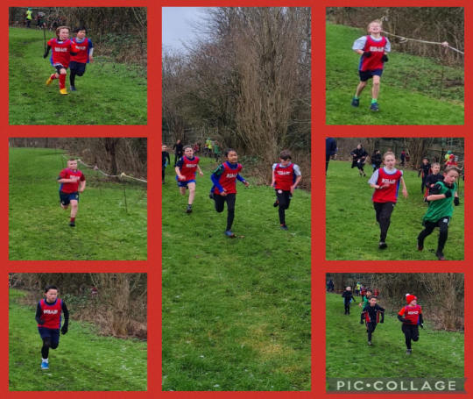
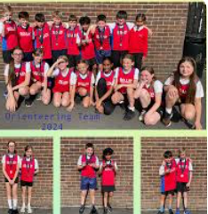
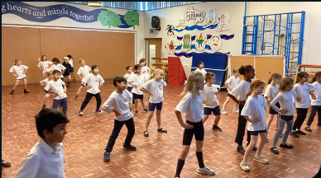

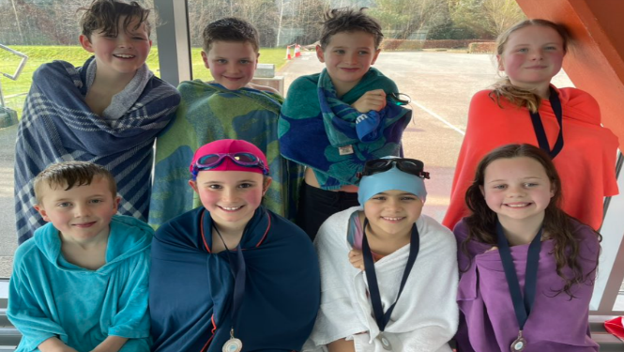
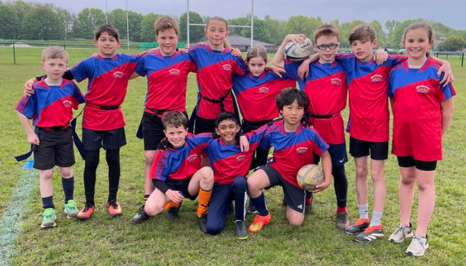

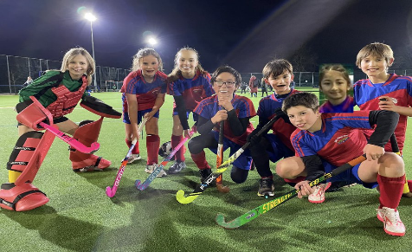
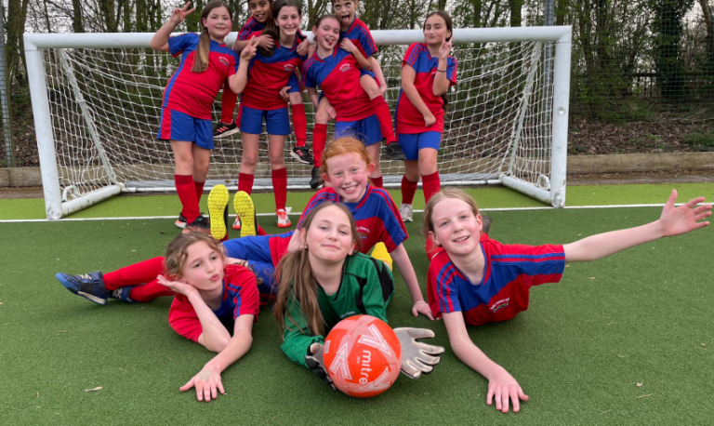
Bollin Primary
School PESP
Report July 2024
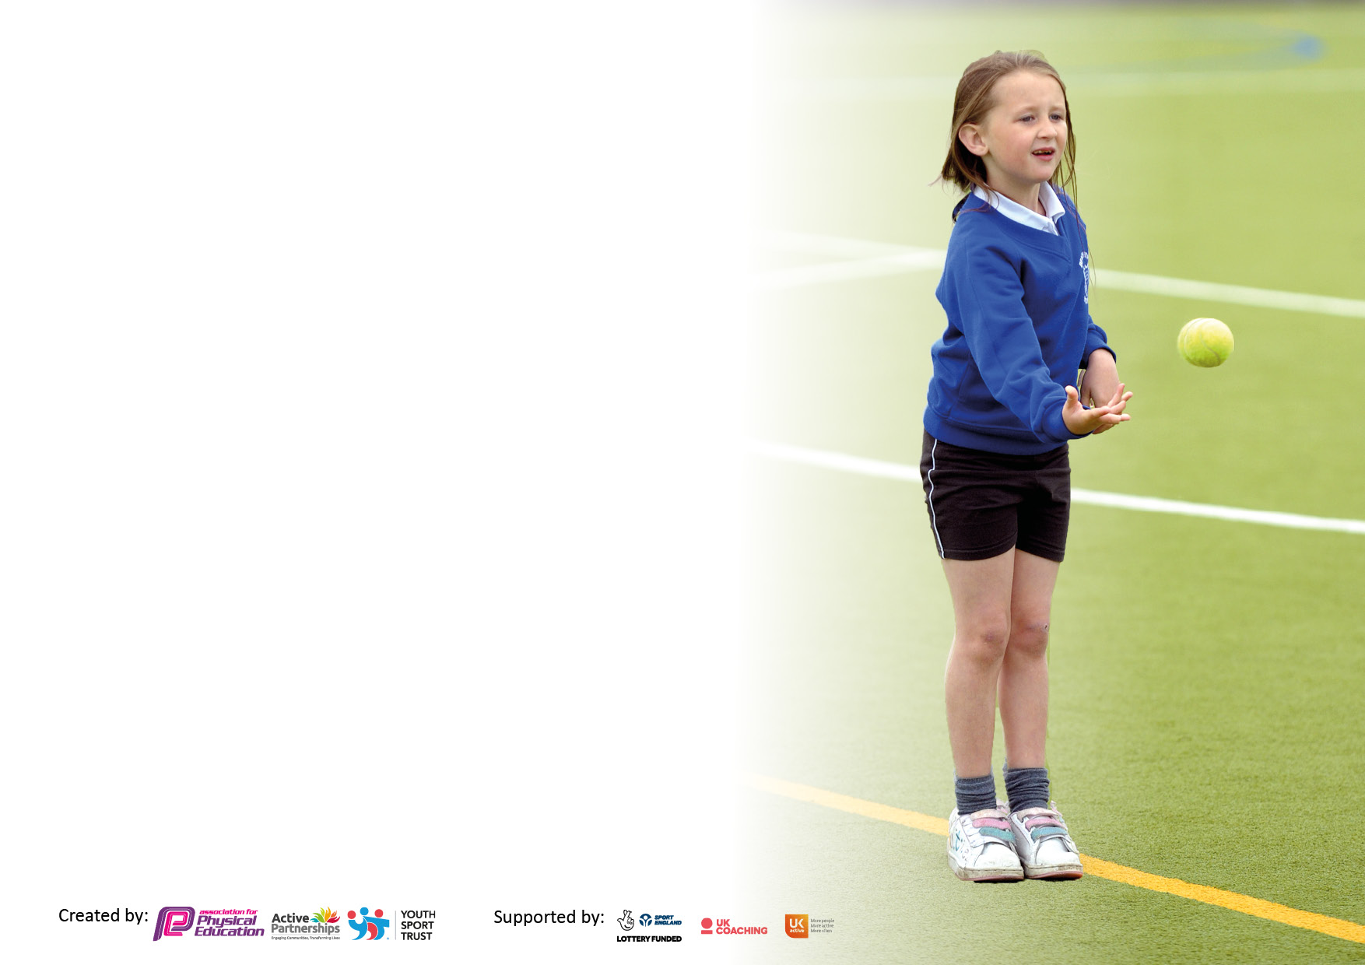
8
Details with regard to funding
Please complete the table below.

Total amount carried over from 2022/23 | £0
Total amount allocated for 2023/24 | £19670
How much (if any) do you intend to carry over from this total fund into 2022/23? | £0
Total amount allocated for 2023/24 | £19670
Total amount of funding for 2023/24. To be spent and reported on by 31st July 2024. | £19670
Swimming Data
Please report on your Swimming Data below.

Meeting national curriculum requirements for swimming and water safety.

N.B. Complete this section to your best ability. For example, you might have practised safe self-rescue techniques on dry land which you can then transfer to the pool when school swimming restarts.
Due to exceptional circumstances priority should be given to ensuring that pupils can perform safe self rescue even if they do not fully meet the first two requirements of the NC programme of study
What percentage of your current Year 6 cohort swim competently, confidently and proficiently over a distance of at least 25 metres?  N.B. Even though your pupils may swim in another year please report on their attainment on leaving primary school at the end of the summer term 2024.  Please see note above | 87%
What percentage of your current Year 6 cohort use a range of strokes effectively [for example, front crawl, backstroke and breaststroke]?  Please see note above | 87%
What percentage of your current Year 6 cohort perform safe self-rescue in different water-based situations? | 87%
Schools can choose to use the Primary PE and sport premium to provide additional provision for swimming, but this must be for activity over and above the national curriculum requirements. Have you used it in this way? | No as no availability at local leisure centre being closed for refurbishment

Action Plan and Budget Tracking
Capture your intended annual spend against the 5 key indicators. Clarify the success criteria and evidence of impact that you intend to measure to evaluate for pupils today and for the future.

Academic Year: 2022/23 | Total fund allocated:£19,670 | Date Updated: July 2024
Key indicator 1: The engagement of all pupils in regular physical activity – Chief Medical Officers guidelines recommend that primary school pupils undertake at least 30 minutes of physical activity a day in school |  |  |  | Percentage of total allocation:
 |  |  |  | 3.5%
 | Implementation |  | Impact
Your school focus should be clear what you want the pupils to know and be able to do and about  what they need to learn and to  consolidate through practice: | Make sure your actions to achieve are linked to your intentions: | Funding allocated: | Evidence of impact: what do pupils now know and what can they now do? What has changed? | Sustainability and suggested next steps:
To:  a. Inspire children to be physically active at break times and during continuous provision curriculum time.  b. Continue to provide a structure for physical activity at lunchtimes and break so that all children have access to space and access to equipment.  c. Enable all to take part safely in an inclusive and supportive atmosphere.  d. Develop cross curricular opportunities for children to be physically active.  e. Meet the Chief Medical Officer  Guidelines for recommended exercise levels | Purchase additional equipment for Playground Leaders to enable them to be physically active throughout the day to provide new equipment to target areas of physical development in line with early learning goals.  Tracks and markings painted onto grass to encourage team work and healthy competition during break and lunch. Also to be used during curriculum time in preparation for sports day and during after school clubs.. | £500  £150 | ‘I love being outside at lunchtime because I get to play the games that the Playground Leaders make up. I get to play with my friends and move around’ Y2  Increased activity during break, lunch and participation at after school club. More pupil engagement particularly from those children who are less confident.  ‘When we have the track painted on the grass we all want to race and I have a great time with my friends doing loads of running.’ Y3  Improved behaviour and engagement in activity during lunchtime | Continue to ensure that we have the appropriate range of age specific equipment to deliver a broad range of physical activities in line with the short and medium term plans which highlight specific skills linked to progression over time.  Continue to offer friendly competition with local schools.
Key indicator 2: The profile of PESSPA being raised across the school as a tool for whole school improvement |  |  |  | Percentage of total allocation:
 |  |  |  | 10.5%
Intent | Implementation |  | Impact
Your school focus should be clear what you want the pupils to know and be able to do and about  what they need to learn and to  consolidate through practice: | Make sure your actions to achieve are linked to your intentions: | Funding allocated: | Evidence of impact: what do pupils now know and what can they now do? What has changed? | Sustainability and suggested next steps:
a. Inspire and reward pupils to take part in Physical Education, Physical Activity and School Sport.  b. Develop children’s values and sportsmanship.  c. Increase children’s confidence and ability to organise and lead  d. For children to understand what they are doing in PE, why they are doing it and the effect it can have on their own wellbeing and others | Current Year 5 pupils took part in a Playground Leaders course with a PE and Sports Hub coach, alongside year 6 playground leaders aimed at training them how to be good leaders and advocates for PE with the younger children.  Purchase of equipment for playground leaders.  This year we have launched Bollin Health and Wellbeing Week. This will provide the children with a week of activities and visitors to engage in tasks to boost physical and mental wellbeing. Each day, every year group will participate in a range of tasks, some delivered by sports companies and other professionals. | £500  £555  £1000 | More of our younger children who are reluctant to engage in competitive sport or find social times challenging are active and participating in team based tasks. This has also had a positive impact on behaviour.  ‘As a playground leader I have taught the year 1 and 2 children to work together and have fun’ Erin Y6  ‘I have helped the year 1’s and 2’s to have more fun at lunchtime and to understand games and teamwork more.’ Archie Y6  Children are able to confidently talk about the benefits of physical activity on their physical and mental wellbeing. They are able to talk about the health benefits and changes that occur in their bodies during and after to physical activity  ‘Physical activity and the wellbeing of children already plays a prominent role in our school but we felt it important to develop and enhance this by delivering a designated Health and Wellbeing Week to incorporate our Sports Days. This would not only allow us to introduce opportunities for physical / wellbeing enrichment and enhancement but would also push a Health and Wellbeing agenda to the forefront of teachers', parents' and children's minds for an extended period of time giving the opportunity for everyone to build on this in the future.’ Mr Matta Y3 teacher and event organiser | Continue to train the current PALS to train and support the new PALS so they are prepared and ready to handover ensuring continuity and a smooth transition. Y5 leaders to shadow y6 leaders during Summer 2  Health and Wellbeing week to be an annual event. We are hoping to engage more outside agencies and stakeholders in the future.

Key indicator 3: Increased confidence, knowledge and skills of all staff in teaching PE and sport |  |  |  |  |  |  |  | Percentage of total allocation:
 |  |  |  |  |  |  |  | 67%
Intent |  | Implementation |  |  | Impact
Your school focus should be clear |  | Make sure your actions to | Funding |  | Evidence of impact: what do |  |  | Sustainability and suggested
what you want the pupils to know |  | achieve are linked to your | allocated: |  | pupils now know and what |  |  | next steps:
and be able to do and about |  | intentions: |  |  | can they now do? What has
what they need to learn and to |  |  |  |  | changed?
consolidate through practice:
To:  a. Ensure all children look forward to high quality, active lessons.  b. Teach lessons that are safe, progressive and exciting and delivered through a broad curriculum.  c. All staff know the social and emotional, creative and physical benefits of PE and build opportunities for children to develop on all of these domains.  d. Ensure that all teachers CPD needs are met so that they can provide the very best climate for learning.  e. Provide support through a scheme of work |  | Employment of an experienced and well qualified sports coach (L5) was appointed to upskill the staff and maintain the delivery of high quality PE lessons.  An annual licence for the PE passport has been purchased | £12500  £715 |  | Greater staff confidence in delivering PE.  More staff delivering or taking the lead in delivery of P.E.  ‘Angela is our best resource. She goes above and beyond to make learning fun but most of all to keep our children active. She is a constant source of inspiration and expertise to our staff, particularly when mentoring and supporting those who are less confident delivering PE lessons.’ Mrs Cosgrove PE lead  ‘I love doing dance because I get to do cool moves and move my body lots.’ Ronnie Y1  ‘Handball is great and Ms George has helped me to get better at catching a ball. I like it because I get to move my body fast.’ Max Y1  It provides a broad, structured progressive scheme which can easily be adapted to meet the needs of our pupils and staff.  ‘PE Passport gives me a framework and scaffold on which to build my lessons ensuring it is progressive and builds childrens’ knowledge and skills. The assessment tool is easy to use , allowing me to track pupil progress, identify children who are not engaging in our provision and intervene when needed.’  Year5 teacher  Greater staff confidence in assessing pupil progress. |  |  | Continue to use Ms George to upskill staff and for staff to do some planning and delivery of lessons alongside her particularly in gymnastics. Staff to progress to delivering more gym lessons.  Continue to monitor staff delivery of high quality PE lessons.  By upskilling staff and helping them to deliver PE with greater confidence, they will be able to seamlessly take over should the funding be withdrawn.  Focus on teaching of dance to upskill staff.  Continue using and adapting The PE Passport to meet the needs of our school community.
Key indicator 4: Broader experience of a range of sports and activities offered to all pupils |  |  |  |  |  |  |  | Percentage of total allocation:
 |  |  |  |  |  |  |  | 2.5%
Intent | Implementation |  |  |  |  | Impact
Your school focus should be clear what you want the pupils to know and be able to do and about  what they need to learn and to  consolidate through practice: | Make sure your actions to achieve are linked to your intentions: |  |  | Funding allocated: |  | Evidence of impact: what do pupils now know and what can they now do? What has changed? | Sustainability and suggested next steps:
To:  - Inspire children through the PE curriculum to want to learn more either through extracurricular club or through local clubs and being active in their community.  - Ensure that the long-term plan caters for all pupils and enables all to display progress across different domains  - Ensure that pupils feel valued and listened to when planning Physical Education, Physical Activity and School Sport |  | Provide a wide range of clubs targeting provision for all children, in particular girls and younger children meaning more children have been active and are forming good active habits. |  |  | Many of our clubs are over subscribed and we have a waiting list.  We have had to tender to outside providers to meet demand for some clubs e.g KS1 multi skills and football  ‘It was tricky to get enough y3 and 4 girls to join football so we joined with the year 5/6 group. We have a girls’ football after school club and the older girls help us to get better. We have developed our teamwork and communication skills’ Year 3 and 4 girls |  |  | Actively market girls football and other sports and signpost them to and promote local teams.  Introduce after school activities that target the less active children or those that do not have opportubities outside of school to participate.  Canvas pupil voice for additional clubs offer.
 |  |  | £500 to provide staff release of y1 teacher to demonstrate and teach this aspect as she competes in this sport |  | ‘I enjoyed showing the older children alternative ways to move and participate in activities outside the normal PE curriculum’ Mrs De Graw Y1 teacher |  |  | Continue entering the girls into local tournaments and continue to involve younger age groups to ensure sustainability  Try to involve local clubs and providers in school to open links to opportunities in the community.

Key indicator 5: Increased participation in competitive sport |  |  |  | Percentage of total allocation:
 |  |  |  | 16.5%
Intent | Implementation |  | Impact
Your school focus should be clear | Make sure your actions to | Funding | Evidence of impact: what do | Sustainability and suggested
what you want the pupils to know | achieve are linked to your | allocated: | pupils now know and what | next steps:
and be able to do and about | intentions: |  | can they now do? What has
what they need to learn and to |  |  | changed?
consolidate through practice:
To:  - Ensure that as many children from Bollin P.S. get the opportunity to play /perform in competitive, inclusive sport.  - Encourage children to take on personal challenges which they own and strive to beat.  - Participate in city wide tournaments and festivals enabling our children to compete against pupils from other schools.  Provide the best available support for those children attending inter school events whilst ensuring that PE lessons still go ahead in school | Bollin again joined the Trafford SSP to enable its students to participate in a range of sports at A, B and C team level.  Cost of transport to a variety of sporting events including orienteering, cricket, football etc  Pupils in years 3-6 have had the opportunity to compete in various competitions across Trafford. Some at Represent level which facilitates access for all pupils to compete at a less competitive level and engage in friendly competition.  Staff attendance at termly SSP leaders meetings | £650  £2,000  £600 | ‘My favourite memory of Bollin is competing in the Trafford cross country races. I won the B race and I had been trying to win since I was in year 3!’ Harry y6  ‘It is so rewarding knowing that our pupils have the desire to compete at many levels and in so many different sports. It teaches our children the valuable lessons of teamwork and collaboration, but also how to lose graciously!!’ Mrs Cosgrove PE lead  After school club participation is high and caters for.  Representation at inter school competitions across different age groups and a variety of sports is high.  Staff kept up to date with latest developments, initatives and be part of a network of sports staff developing links for competition. | Continue to buy into the SSP allowing entry to a wide range of inter school competitions.  Due to the increased transport costs, ask for parent support in transporting children to and from events and competitions.  Continue to promote Represent level competition as well as Elite

Signed off by
Head Teacher:
Date: | 8/7/24
Subject Leader: | Mrs S.L. Cosgrove
Date: | 8/7/24
Governor:
Date: | 8/7/24

