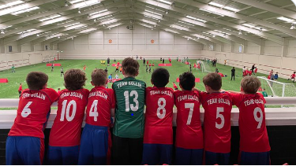

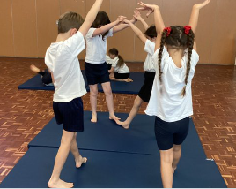
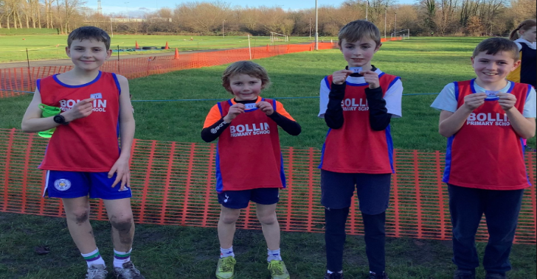
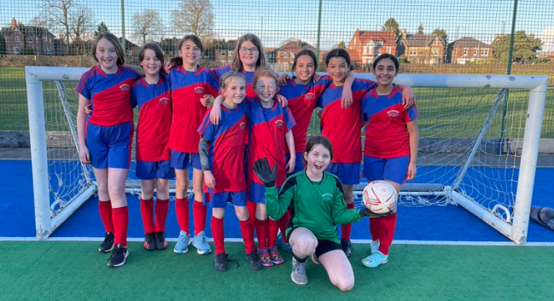
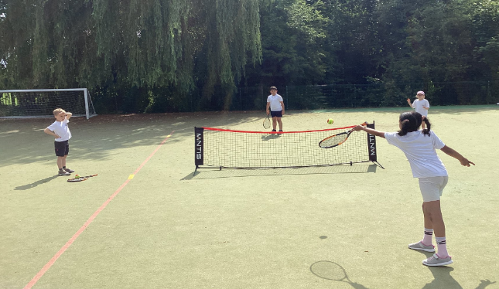

P.E.S.P. Report July 2023

Details with regard to funding
Please complete the table below.

Total amount carried over from 2020/21 | £
Total amount allocated for 2021/22 | £19830
How much (if any) do you intend to carry over from this total fund into 2022/23? | £5825
Total amount allocated for 2022/23 | £19670
Total amount of funding for 2021/22. To be spent and reported on by 31st July 2023. | £19770
Swimming Data
Please report on your Swimming Data below.

Meeting national curriculum requirements for swimming and water safety.  N.B. Complete this section to your best ability. For example, you might have practised safe self-rescue techniques on dry land which you can then transfer to the pool when school swimming restarts.  Due to exceptional circumstances priority should be given to ensuring that pupils can perform safe self rescue even if they do not fully meet the first two requirements of the NC programme of study | 78%
What percentage of your current Year 6 cohort swim competently, confidently and proficiently over a distance of at least 25 metres?  N.B. Even though your pupils may swim in another year please report on their attainment on leaving primary school at the end of the summer term 2021.  Please see note above | 78%
What percentage of your current Year 6 cohort use a range of strokes effectively [for example, front crawl, backstroke and breaststroke]?  Please see note above | 70%
What percentage of your current Year 6 cohort perform safe self-rescue in different water-based situations? | 78%
Schools can choose to use the Primary PE and sport premium to provide additional provision for swimming, but this must be for activity over and above the national curriculum requirements. Have you used it in this way? | No. Wanted to but no availability at pool

Action Plan and Budget Tracking
Capture your intended annual spend against the 5 key indicators. Clarify the success criteria and evidence of impact that you intend to measure to evaluate for pupils today and for the future.

Academic Year: 2022/23 | Total fund allocated:£19,670 | Date Updated: July 2023
Key indicator 1: The engagement of all pupils in regular physical activity – Chief Medical Officers guidelines recommend that primary school pupils undertake at least 30 minutes of physical activity a day in school |  |  |  | Percentage of total allocation:
 |  |  |  | 1250
Intent | Implementation |  | Impact
Your school focus should be clear what you want the pupils to know and be able to do and about  what they need to learn and to  consolidate through practice: | Make sure your actions to achieve are linked to your intentions: | Funding allocated: | Evidence of impact: what do pupils now know and what can they now do? What has changed? | Sustainability and suggested next steps:
To:  a. Inspire children to be physically active at break times and during continuous provision curriculum time.  b. Continue to provide a structure for physical activity at lunchtimes and break so that all children have access to space and access to equipment.  c. Enable all to take part safely in an inclusive and supportive atmosphere.  d. Develop cross curricular opportunities for children to be physically active.  e. Meet the Chief Medical Officer  Guidelines for recommended exercise levels | Purchase additional equipment for EYFS to enable them to be physically active throughout the day to provide new equipment to target areas of physical development in line with early learning goals.  Due to lower intake numbers the Reception classes and Nursery class will be integrated into an EYFS unit allowing all children access to PE Passport and specialist teaching ensuring equipment is appropriate and skills are being taught.  Purchase of an orienteering trail in school grounds which provides physical activity whilst meeting geography, maths, reading objectives and encourages teamwork and collaboration  Tracks and markings painted onto grass to encourage team work and healthy competition during break and lunch. Also to be used during curriculum time in preparation for sports day and during after school clubs.. | £500  £250 (2021-22 spend)  £600  £150 | ‘This year it has been really useful. We have been able to target specific skills for further development linked closely to our EYFS curriculum.’ EYFS teacher  ‘The best part of playtime is the new football posts that we got last year. We have them on the MUGA but we can move them onto the field as well.’ Tom  This is in reference to the purchase of football posts last academic year (2021-22) | Continue to ensure that we have the appropriate range of age specific equipment to deliver a broad range of physical activities in line with the short and medium term plans which highlight specific skills linked to progression over time.  Monitor progress and impact of a clearer defined progressive Physical development curriculum on the development of EYFS children’s physical development.  Continue to offer friendly competition with local schools.
Key indicator 2: The profile of PESSPA being raised across the school as a tool for whole school improvement |  |  |  | Percentage of total allocation:
 |  |  |  | 400
Intent | Implementation |  | Impact
Your school focus should be clear what you want the pupils to know and be able to do and about  what they need to learn and to  consolidate through practice: | Make sure your actions to achieve are linked to your intentions: | Funding allocated: | Evidence of impact: what do pupils now know and what can they now do? What has changed? | Sustainability and suggested next steps:
a. Inspire and reward pupils to take part in Physical Education, Physical Activity and School Sport.  b. Develop children’s values and sportsmanship.  c. Increase children’s confidence and ability to organise and lead  d. For children to understand what they are doing in PE, why they are doing it and the effect it can have on their own wellbeing and others | Year 5 took part in a Playground Leaders course with The PE and Sports Hub and alongside year 6 playground leaders aimed at training them how to be good leaders and advocates for PE with the younger children. | £400 | ‘I love being a playground leader as I love to help the younger children to get fit and healthy’ Eve y6  ‘We had to lead the EYFS transition morning which was a bit scary as we’d never done it before but it was really good in the end and it’s helped me to earn my gold award.’ Phoebe y6 | Continue to train the current PALS to train and support the new PALS so they are prepared and ready to handover ensuring continuity and a smooth transition. Get some of the current Year 4 children to shadow the Year 5’s when they move into Year 6 for the duration of Aut 1 with a view to gaining an insight and taking over at some point.

Key indicator 3: Increased confidence, knowledge and skills of all staff in teaching PE and sport |  |  |  | Percentage of total allocation:
 |  |  |  | 15000
Intent | Implementation |  | Impact
Your school focus should be clear | Make sure your actions to | Funding | Evidence of impact: what do | Sustainability and suggested
what you want the pupils to know | achieve are linked to your | allocated: | pupils now know and what | next steps:
and be able to do and about | intentions: |  | can they now do? What has
what they need to learn and to |  |  | changed?
consolidate through practice:
To:  a. Ensure all children look forward to high quality, active lessons.  b. Teach lessons that are safe, progressive and exciting and delivered through a broad curriculum.  c. All staff know the social and emotional, creative and physical benefits of PE and build opportunities for children to develop on all of these domains.  d. Ensure that all teachers CPD needs are met so that they can provide the very best climate for learning.  e. Provide support through a scheme of work | An experienced and well qualified sports coach (L5) was appointed to upskill the staff.  A dance teacher has been employed to continue to upskill staff and children  An annual licence for the PE passport has been purchased | £12500  £3200  £300 | ‘It is great that we have Angela as part of team Bollin as we can identify individual staff CPD needs which Angela is then able to discuss with the respective staff and upskill them, instilling greater confidence and expertise. Working alongside her facilitates her role not only as a sports coach delivering high quality PE for the pupils but also a mentor for staff. I love working with Angela as she goes above and beyond for all staff and pupils. Nothing is ever too much trouble.’ PE lead  ‘Having The PE Passport allows staff to track pupil progress, identify children who are not engaging in our provision and  provide the structure for a varied progressive curriculum.’ Miss George sports coach | Continue to use Ms George to upskill staff and for them to do some planning and delivery of lessons alongside her. Staff to progress to delivering some PE lessons.  Continue using a dance teacher to deliver high quality dance.  Continue using and adapting The PE Passport to meet the needs of our school.
Key indicator 4: Broader experience of a range of sports and activities offered to all pupils |  |  |  | Percentage of total allocation:
 |  |  |  | 1800
Intent | Implementation |  | Impact
Your school focus should be clear | Make sure your actions to | Funding | Evidence of impact: what do | Sustainability and suggested
what you want the pupils to know | achieve are linked to your | allocated: | pupils now know and what | next steps:
and be able to do and about | intentions: |  | can they now do? What has
what they need to learn and to |  |  | changed?
consolidate through practice:  To:  a.Inspire children through the PE curriculum to want to learn more either through extracurricular club or through local clubs and being active in their community.  b.Ensure that the long-term plan caters for all pupils and enables all to display progress across different domains  c. Ensure that pupils feel valued and listened to when planning Physical Education, Physical Activity and School Sport | The children have been introduced to badminton and volleyball.  For the first time there has been a girls’ football squad in y3 and 4  A cricket coach form the Cheshire Cricket Board has been employed to upskill pupils and staff | £100 for volleyballs  £150 for nets  £350 for badminton equipment  £1200 | ‘I have really enjoyed learning to play badminton this year. It has been really fun.’ Will y3  ‘Following the ladies world cup, more younger girls become more interested. The year 5 and 6 girls had to lead a fun football session with y3 and y4 to encourage them to get involved. Because of that we now have girls football after school club for them. We have developed our teamwork and communication skills and went to the Man U tournament for the first time.’Yr. 6 girls  ‘Cricket has been amazing and I learnt so much as we were getting ready for the Dynamo cricket tournament. It’s good having the same coach for after school club as we get to know him properly.’ Archie y5 | Try to run an after school badminton club.  Continue entering the girls into local tournaments and continue to involve younger age groups to ensure sustainability  Continue relationship with Cheshire CB with staff up levelling staff skills and confidence.  Try to involve local clubs and providers in school to open links to opportunities in the community.

Key indicator 5: Increased participation in competitive sport |  |  |  | Percentage of total allocation:
 |  |  |  | 1050
Intent | Implementation |  | Impact
Your school focus should be clear | Make sure your actions to | Funding | Evidence of impact: what do | Sustainability and suggested
what you want the pupils to know | achieve are linked to your | allocated: | pupils now know and what | next steps:
and be able to do and about | intentions: |  | can they now do? What has
what they need to learn and to |  |  | changed?
consolidate through practice:
To:  - Ensure that as many children from Bollin P.S. get the opportunity to play /perform in competitive, inclusive sport.  - Encourage children to take on personal challenges which they own and strive to beat.  - Participate in city wide tournaments and festivals enabling our children to compete against pupils from other schools.  Provide the best available support for those children attending inter school events whilst ensuring that PE lessons still go ahead in school | Bollin again joined the Trafford SSP to enable its students to participate in a range of sports at A, B and C team level.  Cost of transport to a variety of sporting events including orienteering, cricket, football etc | £650  £400 | ‘Having our own orienteering course in our grounds and having an after school club, we entered the SSP comp and WON for the second year running!.’ Jack y6  ‘It’s so good for the children to represent the school at any level. It gives them an enormous sense of pride and achievement.’ Mrs Cosgrove  After school club participation:  Representatives at inter school competitions:

Signed off by
Head Teacher:
Date:
Subject Leader:
Date:
Governor:
Date:

