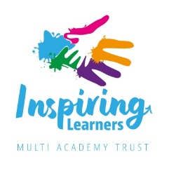
Inspiring Learners Multi Academy Trust Board
 | Role | Term of Office | Date of Appointment | Date ceases | Who elected?
Malcolm Cunningham | Member | - | 05.03.2019 | - | Academy Members
Ged Geoghegan | Member | - | 01.02.2018 | - | GB/Board
Alan Hughes | Member | - | 01.02.2018 | - | GB/Board
Jamie Whyte | Member | - | 13.11.2018 | - | Academy Members
Lynne Bianchi | Trustee | 4 years | 09.02.2023 | 08.02.2027 | GB/Board
Chris Brindley | Trustee - Chair | 4 years | 01.02.2022 | 31.01.2026 | GB/Board
Karen Eccles | Trustee | 4 years | 01.02.2022 | 31.01.2026 | GB/Board
Yvonne Gandy | Trustee | 4 years | 30.11.2022 | 29.11.2026 | GB/Board
Tabitha Gardner | Trustee | 4 years | 01.02.2022 | 31.01.2026 | GB/Board
Kylie Spark | Trustee | Ex Officio | 01.02.2022 | - | Ex Officio
Jamie Whyte | Trustee | 4 years | 01.02.2022 | 31.01.2026 | GB/Board

